This guide assumes that you have a course set up in Gradescope. If you do not, please visit our Gradescope Training page to find additional guides for setting up a new Gradescope course.

A: Setting Up A Bubble-Sheet Assignment
- In Gradescope, create a new assignment and choose the Bubble Sheet format.
Note: When selecting that you want to create a bubble-sheet assignment, Gradescope shows a link to download the Bubble Sheet template!
- After naming the assignment and selecting other options, you should be taken to the Bubble Sheet Answer Key page! Here you can:
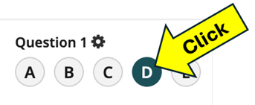
  - Click the buttons to select answers for each question.
For this Guide select answers for questions 1-20. You can just randomly pick answers.
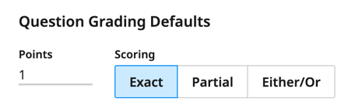
  - In the top-right corner, you can change default question grading rules: question point values and scoring options (for questions with multiple answers). Click on each scoring option to see a description below it.
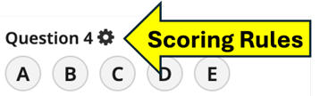
  - Next to a question number, there is a gear icon to set scoring rules for just that question.
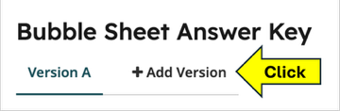
  - Use the +Add Version button at the top of the screen to create a new version of the exam with different answers.
For this Guide create two versions of the answer key and give answer for questions 1-20 on each.
- Press the “Save Answer Key Button”.
You’ve now set up your exam in Gradescope! Let’s upload exams to grade.

Part B: Upload and Manage Student Exams
Note: this process is the same as uploading scanned exams for the Quiz/Exam assignment format.
- Open your Bubble Sheet assignment and go to the Manage Scans page. You may be taken directly there after saving your Answer Key.
- Click on the Select PDF files button and find the PDF (or multiple PDFs) of your scanned student exams. Gradescope will take a few minutes to split the PDF into individual exams.
For this Guide you can find sample student exams to upload for exploring and testing on our Gradescope Bubble Sheets page, (probably the same page where you got this Guide.
Before uploading the samples to Gradescope, look at the sheets. How does Gradescope tell students to mark answers? Did students follow those instructions? Are there any other weird things students did? What might Gradescope do with those weird answers?
- Press the Manage Scans button in the bottom-right corner. On the Manage Scans page, Gradescope will try to match student names on the exams to students in your Gradescope roster (if there are students in the roster).
For this Guide you may not have students in your roster that match names on the sample Bubble Sheets. Gradescope will just list all student names as Unknown Student. That’s fine. You can continue to explore without names in Part C below.
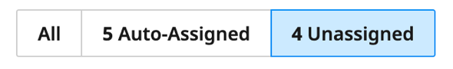
- For exams that Gradescope could not match, you’ll need to manually assign exams to students. Click on the (Number) Unassigned button.
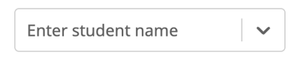
  - An updated exam list appears on the screen. In the list, you are shown a picture of what students wrote in their Name and ID number boxes. Next to each image is a box (shown to the right) for you to choose the student’s name for that exam.
  - When you click in the box, a drop-down list of students appears. If you begin typing a student’s name, the list will update to show only student names that match what you’ve started to type.
  - Click on a student’s name to in the drop-down box to assign that exam to the student.
  - Students who have already been matched to an exam are grey-ed out in the list.
Students are now matched to exams! Time to Grade!

Part C: Fix Uncertain Student Answers
Gradescope will analyze each bubble sheet and automatically grade what students answered. This may take a few moments depending on student count, number of questions, and number of exam versions. Once it finishes, there may be some answers that Gradescope struggled to identify. You must help it!
- Go to the Grade Submissions page of your Bubble Sheet assignment.
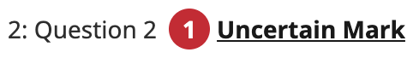
- You should see a list of question. Some may have a red circled number next to it. Click on the linked text “Uncertain Mark”.
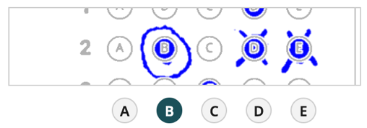
- A small, embedded window will open that asks you to review student answers. The window shows pictures of what students marked and under each picture are answer buttons. The marked buttons are what Gradescope thinks the student answered, but it isn’t confident. You can:
  - Click un-selected buttons to select them if students chose that answer.
  - Click on selected buttons to unselect them if Gradescope incorrectly chose it.
After correcting answers for all the uncertain markings, click on the Confirm All Marks button to finish with this question.
- For each question with Uncertain Marks, review the marking and confirm students’ selections.
Gradescope has now graded all student exams! See their scores on the Review Grades screen.

Part D: Fix Unknown Exam Versions
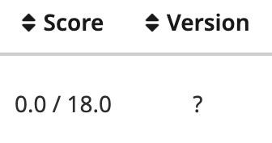
On the Review Grades screen, if you have multiple exam versions, some students may have a score of 0.0 and a question mark in the version column, as shown to right. These are exams where students did not mark an exam version or Gradescope could not interpret how they marked the version. You need to select the version for the student (you can do this without matching student names first).
- Go to the Manage Submissions page of your Bubble Sheet assignment.

- Above the list of exams, find the red circled number next to Uncertain Versions. Click the “Uncertain Versions” link (the text is a link).
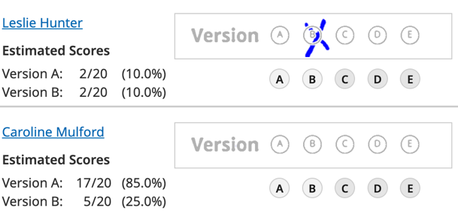
- An embedded window opens for you to review uncertain exam versions. The screen shows what students marked in their Version box and what score they earned when grading their exam with each version’s answer key, as shown to the right.
  - If it is clear to you what version was marked, click the box under the image to tell Gradescope which version to grade with. This is the case for the first exam in the image.
  - If it is unclear what version was marked, you must decide how to choose which version to grade with. This is the case for the second exam in the image.
If you collected the question packets from students after the exam, you could look through the exams to see if the student wrote their name on their packet. If you cannot locate their packet, you could choose the version where students earned the highest score.
- Click the Confirm Versions button.
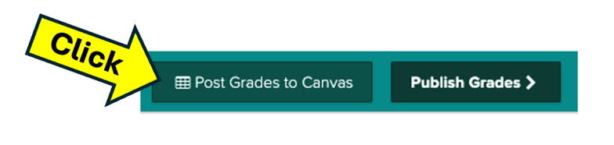
All students should now have grades for their exams! If your Gradescope course is linked to a Canvas course, and you have synched rosters, you can export scores to Canvas using the Post Grade to canvas button at the bottom of the Review Grades page.

