Four Steps of Integrating Canvas & Gradescope

Step 1: Link Canvas & Gradescope Courses
In your Canvas course, go to the Assignments page.
Click the three-dot menu in the top-right corner, select Gradescope from the list.
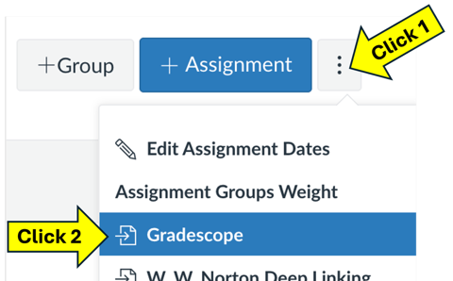
In the window that pops up, you can create a new Gradescope course or choose a Gradescope course you’ve already started building.

Step 2: Sync Your Canvas Roster to Gradescope
In your Gradescope course, go to the Roster page from the left side-bar.
Click the ^More button at the bottom of the screen, and then choose Sync Roster to Canvas. If this option is missing, your courses are not linked.
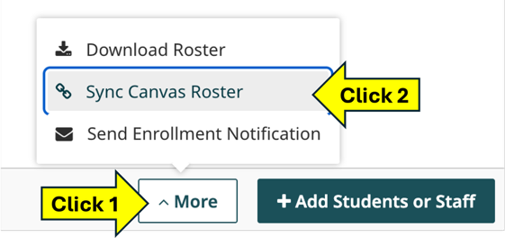
The first time you sync rosters, we recommend turning on the setting to email students a notification that they’ve been enrolled in the course. We also recommend talking about Gradescope with your students before you have it email students, so they do not just get an email from some unfamiliar website about your course.
If your Canvas roster changes, Gradescope does not automatically update its roster. You must manually sync the rosters again. When you re-sync rosters, we recommend turning off the setting to email students.

Step 3: Link Assignments in
Canvas & Gradescope
In your Canvas course, go to the Assignments page. Create a new assignment with the
+ Assignment button in the top-right corner (or you can edit an existing assignment).
Set up the assignment in Canvas as you normally would (with instructions, a due date, etc.). Then, for the Submission Type options:
- Select External Tool from the drop-down menu
- Check the Load This Tool In A New Tab box
- Click the Find button.
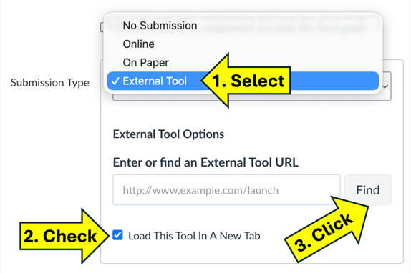
- Select Gradescope from the list of tools.
- In the window that pops up, you can create a new assignment in Gradescope or choose an assignment that you have already set up.
You can do this step without having synced rosters.

Step 4: Copy Grades into Canvas
In your Gradescope course, open a graded assignment and go to the Review Assignment page from the left side-bar (bottom of menu).
Click the Publish Grades> button in the bottom-right corner. This lets students view grading details and assignment feedback (through Gradescope).
Click the Post Grades to Canvas button in the bottom-right corner. This copies scores into your Canvas Gradebook. If this button is missing, your rosters have not been synced or the assignment is not linked to an assignment in Canvas.


