Part A: Making a Homework Assignment
This type of assignment can have multiple individual questions (or question parts) for students to answer. Students can upload their answers directly to Gradescope for you to grade.
- From the course page in Gradescope, go to the Assignments page (the second item in the list). In the bottom-left corner, click the “Create Assignments” button.
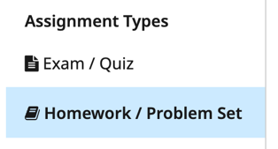
  - Note the “Duplicate Assignment” button. This button will show you a list of all your courses and within each course you can select an assignment to copy to this course. It will copy all the settings for the assignment, and any grading rules (the assignment rubric) for the assignment.
- Select that you want to create a “Homework / Problem Set” assignment and click “Next” to go to the Assignment Settings page. Give your assignment a name that helps students easily identify it.
- For a Homework / Problem Set assignment, you must upload a pdf template for the assignment. This can be a copy of your instructions, a list of questions to answer, a list of problems from your textbook to do, or whatever you want. Upload some pdf from your computer, I guess.
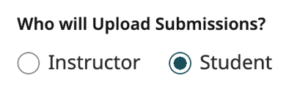
  - At the bottom of the Assignment Settings, there is a “Allow students to view and download the template” option. If you do not select this option, you must give instructions for your students in another format. Even if you do select this option, we recommend include the instructions in your Canvas assignment, not just in Gradescope.
- Leave the “Who Will Upload Submissions” setting as Student. You can still upload submissions for individual students, if needed.
- Choose a Release Date (the date students can begin submitting answers) and a Due Date for the assignment. What happens if you select a due date that is before the release date?
- Turn on the Allow Late Submissions setting.
  - What happens if your Late Due Date is before the Release Date? What it is before the Due Date?
  - In Gradescope, students who submit work after the due date, but before the late due date, will have their submission labeled as LATE. Gradescope does not automatically apply any penalty; you will have to manually apply a late penalty if you want one.
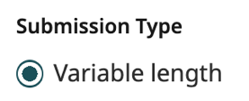
- Set the Submission Type setting to Variable Length. This lets students submit any number of pages/images for their work. Students will be prompted, but not forced, to mark where each question is answered in their assignment.
  - For the Variable Length assignment, when you create questions for the assignment you just must make a list of question names with their associated point values. We will do this next.
  - If your assignment is a worksheet or other assignment with a specific format, you can use the Templated format. We will explore this in the Exam/Quiz assignment making.
- If you want students to be able to submit group assignments, enable the “Enable Group Assignments” setting.
  - After submitting their work, students will be able to add group members names to their submission.
  - When you grade the submission, all in the group will see your feedback and earn the same score.
- The two Create your Rubric options have very little difference. In either option you can create a rubric before students submit work, before you start grading submitted work, or while you are grading. The only difference is that if you select “Before student submissions” you will be prompted to create the rubric right after you finish making the assignment.
- Click the “Next” or “Create Assignment” button in the bottom left-corner.
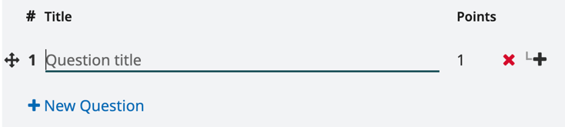
  - If your students are arranged into sections, the “Next” button takes you to the Customize Sections page where you can assign it to only specific sections or adjust dates for each section individually. For example, you can change the date/time so students are only able to submit an assignment during their discussion section to (help) enforce attendance. After setting up the sections, click the “Create Assignment” button in the bottom-left corner.
- You should now see the Create Outline page. It will show your uploaded template on the left and an outline with a question list on the right. Click the blue “+ New Question” link to create a question.
  - For each question, you add a title and a point value. That is all. You do not input question prompts directly into Gradescope. You can title your question with just a number or with a short description.
  - Clicking the “+ New Question” button again will add another question. Create four total questions with differing point values. Where are you shown the total point value for the assignment?
  - What happens as you roll your mouse over the list of questions in the outline?
  - You can delete a question with the red X symbol in the question list. Delete question 4.
  - Rearrange your questions by dragging the four-way arrow symbol to the left of a question number.
  - Add a new question number 4 and give it a title. Instead of giving it a point value, click the plus sign symbol next at the end of the question line. This lets you create a sub-question for question #4 (for example, you can make parts A, B and C). Give your sub-question a title and point value.
  - Add a few more sub-questions to question #4. What happens to the point value for question #4?
- Click the “Save Outline” button and your assignment is created!
  - If you chose to create your rubric “Before student submissions” you will be taken to the Create Rubric page where you can start to define grading rules for each (sub-)question.

Part B: Making an Exam or a Quiz
An Exam/Quiz assignment is set up for you to grade hand-written exams/quizzes that are uploaded into Gradescope. They are just like the Homework/Problem Set Assignment type but, by default, use (1) the Instructor upload setting and (2) the “Formatted (Fixed Length)” submission type settings.
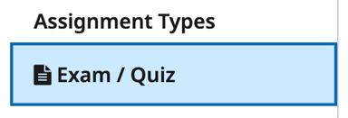
    - Create a new assignment and choose the “Exam/Quiz” assignment type.
    - Give the Exam/Quiz a name and use our “TEPSampleQuiz.pdf” file as the template.
- In the other settings, which ones do you notice are missing from the homework assignment type?
- What settings appear if you change the “Who Will Upload Submissions?” setting to Student? Be sure to change it back to “Instructor” before adding questions to the quiz.
    - The Enable Anonymous Grading setting will show names as random number/letter strings (such as “Student SBX4 FPQ6”) and will black out where student names and ID numbers are written.
      - Like in Canvas, you can toggle this setting on/off at will and hide/unhide student names at any time. It is not the most secure for student anonymity.
      - If this setting is turned on, you won’t be able to see that Gradescope has correctly matched hand-written student names to your class roster. After you finish grading, turning off Anonymous grading will let you check student name matching (see step 11 below). Alternatively, leave this setting off, match names after your upload exams, and then turn the setting back on to hide names while grading.
    - After selecting settings (and managing class sections if needed), you will move to the Outline page. You will see a copy of the uploaded template on the left and the quiz outline on the right.
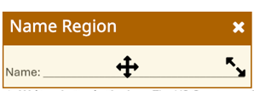
    - Click on the Edit Name Region button to tell Gradescope where to look for student names. After uploading exams, Gradescope will try to match hand-written names in this box to students.
      - The button will create an orange box on your template (see right). Click the center of the box to drag it around the template. Use the diagonal arrows in the corner to resize the box.
      - Place the Name Region box around the Name blank in the top-left of the page.
    - If you want, click on the “+Create ID Region” button to mark where students have written their student ID number on the exam. On our template, this is in the top-right corner of each quiz.
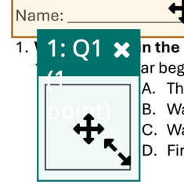
    - Question 1 is a multiple-choice question where students write a letter for their answer. On the template, click and drag to create a question region around the where students will write their answer. This will create a blue-green box on your template and will add question 1 to the outline. The box tells Gradescope where on the page students’ answers are written. For each scanned student exam, it will focus on just this region of the page to find answers to question 1.
      - Give the question a title and set it to 1 point. For this exploratory quiz, maybe use a title that identifies the type of question it is (multiple choice) to remind yourself how to approach grading it later.
    - Question 2 is a fill-in-the-blank style question where students write their answer on the line. Click the blue “+ New Question” link at the end of the outline. Another blue-green box should appear on the template. Move and resize the region to be around the answer blank for this question.
      - Give the question a title and set it to 1 point.
    - Question 3 is a short answer question where students can write in whole bottom-half of the page.
      - Create question 3 on the bottom-half of the template. Give the question a title and set its point value so the total quiz is worth 10 points.
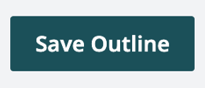
    - Click on the “Save Outline” button. You now have a quiz in Gradescope!
      - If you chose to create a rubric before student submissions in the assignment settings, you will go to the Create Rubric page. You can skip this step for now and click on the Manage Scans page from the assignment’s left sidebar.

Part C: Uploading Completed Student Exams
For an Exam/Quiz Assignment, you can upload scans of completed student exams/quizzes into Gradescope. This digitizes hand-written exams so you can grade them in Gradescope.
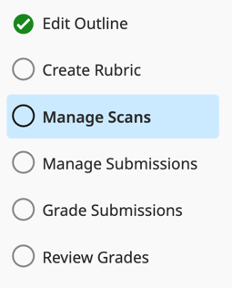
You must upload scans to Gradescope as PDFs. Instead of uploading exams individually, we recommend you upload a batch of student exams in one PDF and then Gradescope can split the PDF into individual exams for students. You can upload multiple PDFs, though. For example, a four-page exam for 80 students makes one very big PDF when scanned. Instead, having four PDFs with 20 exams each may be easier to process by scanners and Gradescope.
- Go to the Mange Scans page in the assignment left sidebar. Click on the “Select PDF Files” button and upload the file “TEPSampleSubmissions.pdf” which has sample student solutions for our sample quiz.
      - After uploading the file, Gradescope will “Extract pages” and “Find Split Points”. This means that Gradescope is trying to find where one quiz ends and the next starts by comparing pages in the PDF of scanned exams to the exam template.
    - If Gradescope is comfortable with splitting exams, it will show you green text that tells you how many submissions (individual exams) it found. If it has a problem, it will show orange text and invite you to fix the problem(s) it found while making submissions.
      - Click on the “Show” button under the pdf file name and scroll through the submissions. Which one(s) looks different from the others? Fix the problem(s) using one or more of these options:
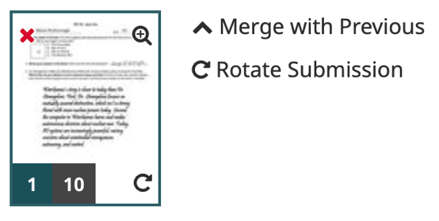
        - If one submission was incorrect split into two, click on the “⌃ Merge With Previous” link on the second submission to combine it with the previous one.
        - If two submissions are incorrectly combined into one, click the space between two pages of the submission to “split” it into two submissions at that point.
        - If just one page is rotated, you can hover your mouse
over a page and click the rotate symbol in the bottom-
right corner of a page to rotate it until it is upright.
        - If a whole submission is rotated, you can click on the “Rotate Submission” link to rotate all of it.
        - If there is an extra page(s), click hover your mouse over the page and click the red “X” icon to delete it. A submission could have extra pages that you want to keep though, for example if a student continues an answer onto a blank paper. You don’t have to delete extra page(s).
        - If pages are out of order, you click and drag pages within a submission to reorder them.
        - If a page image is too small to see, hover your mouse over the image and click the magnifying glass icon to see the page in full size to help you decide how to fix any problems it may have.

After you’ve fixed the problem(s), scroll to the bottom of the list of submissions and click on the “Create # submissions” button. Hopefully, you have 24.
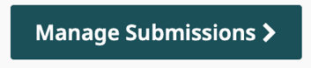
    - Click the “Manage Submission >” button (or go to the Manage
Submissions page in the assignment left sidebar) to match written
student names to your roster. Gradescope will first try to read the
hand-written names and match them to students. After it processes names, you can verify its matches, correct any mistakes it made, and match exams that it could not assign to a student.
      - Gradescope will show you a picture of the Name Region of each exam and list the student it matched to that exam. If there are names Gradescope cannot identify, there will be no name listed.
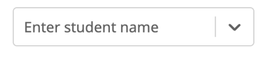
      - To match unassigned exams, click on the “Enter student name” box and scroll down to find a student (you can also start to type a name to filter the list). Greyed out students in the list are already matched to an exam.
      - There should be one unassigned exam. Who is the unassigned exam for? Match them to the exam.
      - To correct a mistaken match, click the “Edit” button next to a student’s name and then reselect a new student with the Enter Student Name box that appears.
      - If you are using anonymous grading, Gradescope will tell how many exams are unassigned, but you won’t be able to match them manually unless you turn off anonymous grading. If you want to keep the exams anonymous, you should first finish grading the assignment fully, then turn off anonymous grading (in Assignment Settings), and then finally match the unassigned exams.
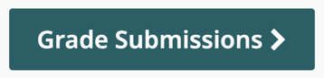
    - Clicking the “Grade Submissions >” button will take you to list of assignment questions. You are now ready to grade!
      - You can go to the grading page any time. You don’t have to finish matching exams to students to start grade their work.

