Part 1: Creating A Grading Rubric
Participant
Number
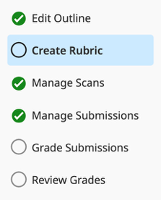
In Gradescope, all grading rules that you define are called a Rubric. This can include a “traditional” rubric arranged in a grid with different categories, but it can also just be a list of mistakes, details, answer features, qualities, etc. with an associated point value. When you grade a question, you just select items from the rubric. You can also create new items in the rubric as you grade if needed.
- In the Gradescope Dashboard (or the Assignments page), open the assignment titled Quiz – Participant # (where # is your participant number). On the left sidebar, select Create Rubric (2nd on the list after “Edit Outline”). This page lists all questions in the assignment and the rubric for that question. Each question in an assignment has its own rubric and its own list of comments (created after you start making comments on student work).
  - There are three questions in this sample quiz – a multiple choice, a fill in the blank, and a short answer.
  - In the rubric creation page, each question has a list of rubric items (you may also see an image of the question). Each rubric item has a description and a point value (colored red or green); you can edit both. Both are shown you students when they review their scores after you finish grading.
- Question 1 (multiple choice) currently uses a scoring method called Negative Scoring, which subtracts points from a student’s score for each rubric item you select. This can useful when you are grading for mistakes that students make but might not be useful for multiple choice questions.
- To change scoring rules, click on the blueRubric Settings link above the rubric item list. Change the options to “Positive Scoring (points are added to 0)” for question 1. Note the other options, including the note how to change scoring options for all questions in an assignment (don’t do it now).
- Save your changes. What happened to the “Correct” item’s point value after you changed this setting?
- To change the point value for a rubric item, click on the colored number and enter a new one. Change the “Correct” rubric item to 1 point. When you select that item, a student will earn 1 point for that question (why the value includes the positive sign).
- Even with positive scoring, you can still assign negative points to a rubric item to take away that number of points when you select that item. Try using a negative value. What happens to the value?
- When students review their assignment, they will see the description of a rubric item, so let’s change the rubric item description to be more useful. Click on the description (“Correct”) and change it to “B is correct!”. This both shows students the right answer when they review the assignment and it helps you remember which answer is correct while you grade.

- To add a rubric item, click the + Add Rubric Item button under the rubric for this question.
  - For the new rubric item, give it 0 points and make its description “Answer A is incorrect because …”
  - In a real assignment, it is good practice to include an explanation for why an answer is correct or incorrect. Because students will see these descriptions, this helps students understand how you’ve graded them (and can minimize students asking why their answer is wrong after you finish grading).
- Add two new rubric items that describe answers C and D as incorrect (scores of 0).
  - When you grade this question, you can just match student answer letters to the same letter rubric item.
- Question 2 is a fill-in-the-blank question (students recall who the first US president was). Create a positive-scoring rubric for question 2 with just two items: correct answer or incorrect answer.
  - When you grade this question, you’ll just choose between these (or maybe need to add more?)
- The third question is a short answer question where students are asked to choose between two movies and asked to provide two examples from their movie to justify their choice. Each example, along with the reasoning, is worth 4 points (for a total of 8 points for the question). There is a not a “correct” movie choice, so we only care about the explanations for their answer when we grade.
  - For question three, use the rubric’s settings to use Negative-scoring Grading. We will be taking away credit for mistakes in how well students justify their answers.
  - The one existing rubric item takes away no points and is for a fully correct answer. Update its description to give more context about what a fully correct answer might be (a well justified choice using two examples from the movie).
- You cannot use a rubric item multiple times for the same submission. If a student makes the same mistake for both their movie examples, if you try to click a rubric item twice, you will just deselect it. If we want to grade each example by itself, we will need rubric items for each example. This is a good use of rubric groups. Click on the “Create Group” button under the rubric.
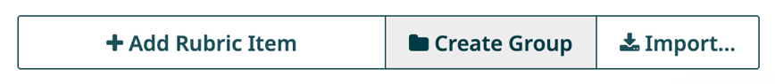

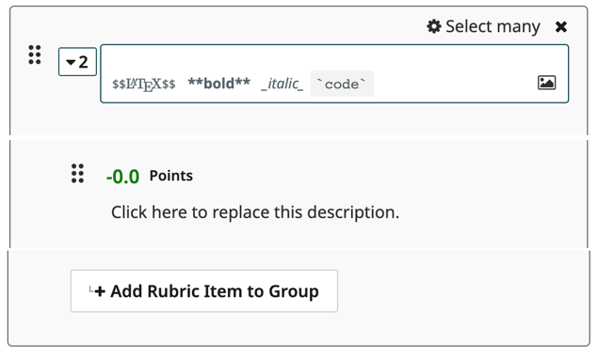
  - This will create a new rubric item, listed under a group title, as shown to the right. If you aren’t prompted to title the group after you create it, you can click on its description to edit it.
  - Title the group “Example 1”. Give the rubric item a description of “Explanation unclear” and with a score of -2 points.
  - Add another item to the group using the “+ Add Rubric Item to Group” button. Give it a description of “Explanation missing” with a score of -4.
  - Add a third item to the group. Give it a description of…oh wait. We only wanted two items. Delete a rubric item with the x button in the top-left corner of its card.
  - You can open and close a group by clicking on the numbered box next to its description (clicking these boxes while grading will select which rubric item to apply to a question).
  - Create a second group for example 2 with the same rubric items as for example 1. Now you’ll be able to select the same feedback for each example by selecting the two different rubric items.
You now have a rubric to grade your quizzes! Do note, you do NOT need to create a rubric before you being grading student work. You can create a rubric (or edit an existing one) while you are grading.

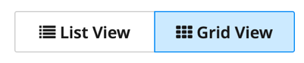
Bonus Task – Grid-based Rubrics
- In the top of the Create Rubric window, click on the “Grid View” button.
  - How do the individual (non-grouped) rubric items in questions 1 and 2 appear?
  - How do the individual rubric items in question 3 appear?
  - How do the grouped rubric items in question 3 appear? Does each group appear as a row or a column of the grid-rubric? Does each individual rubric items appear as rows or columns in the grid-rubric? How/where do the points for each item appear in the grid-rubric?
  - Go to List View and add a third item to only one of the groups. How does that appear in Grid view?
  - Go to List View and delete your third item. Edit the “Explanation Unclear” item in the group to be -1 point (leave the other group at -2 points for this item). How does that appear in Grid View? What happens if you change the score for that item back to -2 points in Grid View?

Part 2: Forming Answer Groups
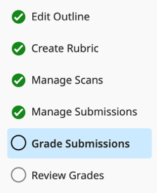
For some response types, Gradescope can form groups of student answers. It will convert student writing to digital text and match when students have written the same thing. This is useful for (very) short answer questions (just a word or phrase), numerical answers, or a written letter. It can also identify when students fill in certain bubbles for multiple choice questions. After student answers are grouped to identical answers, you only need to grade ONE answer and everyone in that group will get the same points and feedback for that question.
- To start grouping, click on Grade Submissions in the assignment left sidebar.
- Click on the number/question name for question 1. You will be able to choose if you want to grade every student answer by itself (individually) or if you want to Form Answer Groups First. Choose to Form Answer Groups.
  - Which grouping option makes sense for this question? (Hint: what do the sample student answers that Gradescope shows you look like?)
- After choosing to form groups by Text fill-in-the-blank (students are writing a letter), click the Review Answer Groups button. Gradescope will take a moment to process answers by converting the handwriting to digital text and then form groups for all different things students write.
- Next, you must review groups and deal with answers that Gradescope could not read/match.
  - Gradescope will show you how many groups it formed and one example for that group.
  - From this screen, you have the options to rename a group, merge a group with another (for example, if you want all capital B’s and lowercase b’s to just be in the “B” group), or delete a group.
- After you are okay with groups Gradescope made, you have the review the answers in each group to make sure Gradescope put them in the correct groups You can do this by clicking on one of the groups or clicking on the “Review First Group” button in the bottom right corner.
  - When reviewing a group, if an answer does not match the others in a group (if Gradescope misidentifies some text for example), you can just click on its image and Gradescope will remove it from the group. How does Gradescope highlight which answers you want to remove?

  - After you remove any incorrectly included group members (if there are any), click on the “Confirm & Review Next Group >” button.
- Are any of the answers in the group unclear? If you hover your mouse over an answer, you can zoom in or out (magnifying glass icon) or view the whole student exam page (arrow named Preview Submission). This may help you better identify an answer if you are unsure if the grouping is correct.
- After reviewing and confirming all groups, Gradescope will show you the remaining ungrouped answers – ones that it could not understand or ones that you removed from other groups. The ungrouped answers are shown in a grid for you to quickly review.
- On the right side of the screen, Gradescope shows the existing groups. You can click and drag an ungrouped answer into an existing group to make it part of the group. You can also click on multiple answers and then drag them all to the same group.

- You can form a new group if needed by clicking on the “+ Create a Group”
button on the top of the page. You will be prompted to give the group a
name. If you have selected one or more answers before creating a new group, the selected answers will be put in the group automatically. You can leave answers ungrouped, and then you will need to grade those individually.

- After you’ve formed groups, click on the “Grade Answers >” button to start!

Part 3: Grading Basics (Grouped Answers)
If your questions already have a rubric, you can jump into grading student submissions (or groups of submissions) with them.
- To start grading, click on the Grade Submissions option (second to bottom). Then click on the question/number you want to grade - question 1.
- If you haven’t yet chosen to grade by group or individually, you will be asked to.
- If you have grouped answers for this question already, you will be shown the groups again. Click on the “Grade Answers>” button to start grading.
- If you have chosen to grade individually, you will be taken to the first ungraded student answer.
- On the left, there is a student submission to grade (or an example from a group if grading by groups). On the right is the rubric where you can select items to assign to this submission.

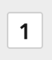
  - You can select rubric items by clicking on the number in a white box next to the rubric item (see left image). If you have more than 10 items in your rubric, some boxes might not have numbers (see right image); they will just be blank boxes.
  - For the first group, click on the appropriate number box for its rubric item (use the rubric item descriptions to help you). What happened to the number-box? What happened to the “Total Points”?
  - If you are grading by groups, every student that is included in this group has received this same grade, but you only had to grade one example of this answer!
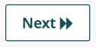
- Click on the “Next >>” or “Next Ungraded >” button to view the next submission.

  - The “Next>” button just moves to the very next answer (or group), regardless of if you have graded it already. The “Next Ungraded >” button skips work you’ve already graded and goes to the next submission you need to grade. This is helpful if you want to go back to review previously graded submissions for any reason.
- You can also select rubric items by typing the boxed number on your keyboard. Try it for the current group. Did the number-box and the Total Points update as expected?
- You can also move between submissions using your keyboard. Click on the Keyboard Shortcuts (Shift+?) button at the top of the right side of the screen. What is the button that will take you to the next ungraded answer? Type it and then grade the next group only using your keyboard.
- Finish grading this question and you will be taken back to the Grade Submission page.
  - In the question 1 area, how has the progress bar changed to show that you finished grading the question? Your initials show that for question one, you formed groups and you graded answers.
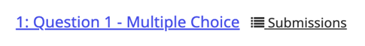
  - When you mouse over the question, a “Submissions” link pops up. What happens when you click it? Quickly scan the list and verify that only students in the “B” group earn a point for this question.
- After grading, you realize that answer D was worded poorly and, in some contexts, could be correct. You decide to count answer D as correct too.
  - Go to the Create Rubric page and edit the score (make it 1 point) and description for answer D.
  - Now view Submissions for question 1 from the Grade Submissions page. What score do students who are in the “D group” have now?
- Form groups for question 2 however you feel is appropriate. Grade the groups (the correct answer is George Washington).
- If there are answers or groups that might not fit nicely into the correct/incorrect options you made, you can make a new rubric item while grading a submission. Just click the “+ Add Rubric item” button!

Part 4: Advanced Grading (Individual Submissions)
For question 3, students are asked to choose a movie and support their answer with two examples from the movie (each example is worth 4 points). These instructions will mostly tell you how to grade each answer, you won’t need to try to evaluate the sample answers.
- Use the Grade Submissions page to begin grading question 3. Because this is a short answer question, you won’t be able to form groups. Select the Grade Individually option.
  - As you grade, submissions are shown in the order they were uploaded to Gradescope.
- For grading, we created a group for each explanation. Let’s practice using rubric groups.
  - Look at the number boxes for the group heading and rubric items in a group. What do you notice about them? What happens to the number-boxes when you select a rubric item in a group?
  - What happens if you try to select both rubric items in one of our groups? Does this make sense for how we’ve set up this rubric? Hover over the Group header card and click on the “Select Many” link. Change this setting to “Select One”. What happens if you try to select both now?
  - Practice grading with the groups for the submissions 1 and 2 (randomly pick options and explore).
- On submission 3, you find a new mistake we don’t have a rubric item for! Luckily, you can edit rubrics as you grade. Add a new rubric item with the “+ Add Rubric Item” button that takes away -4 points and has the description “Example doesn’t support your answer.”

  - Whoops, we wanted this to be part of the group for Example 2, not its own rubric item. You can rearrange any rubric items with the six-dot icon in a rubric item’s card. Click on the six-dots icon for the new rubric item and drag it into the Example 2 group.
  - What happens to the number-boxes for rubric items when you rearrange the rubric items?
- For submission 4, update the new rubric item. Add “(opposite is actually true)” to its description.
- For submission 5, grade the answer as you think is appropriate (create rubric items if needed).
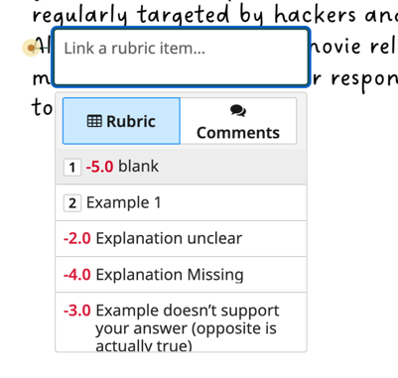

- For submission 6, let’s add annotations to the student’s answer
to highlight specific things in the answer. Move your mouse over
the submission (left side of screen) and the annotations menu will show up (see above). With the navigation tool (the hand/finger), you can double-click on a place in the submission to leave an annotation at that specific point.
  - Find where the second example starts and double click near it. When a textbook opens, click the “Rubric” box to see a small version of the rubric (see image on right). Select “Explanation Unclear” for example 2.
  - If the “Select Many” option is chosen for a group, selecting the rubric item with the annotation menu will also apply the rubric item to the submission! We used the “Select One” option, so you will need to manually select the rubric item after linking an annotation to it.
  - Click on the annotation you’ve just added. Then click the “Add
comment” button to leave a detailed comment. This highlights for
students where their mistake was and your comments can highlight how to improve for next time. It gives them information to understand your grading than just seeing a list of rubric item descriptions.
  - Explore with the other annotation tools. Which let you add written comments or link to a rubric item? To remove an item, use the eraser tool by clicking and dragging it across what you want to delete.
- For submission 7, we can reuse an annotation for this submission. Add an annotation and click on the “comments” button when the annotation menu pops up. Then click on an annotation to reuse it! Check that it also shows up in the rubric list (and select it in the rubric if needed).
- For submission 8, make a new annotation for example 1 that that says the example is unclear. Also reuse the annotation that example 2 is unclear. Since both examples are unclear, there may be a bigger idea the student is missing.
  - Below your rubric is a textbox where you can make specific comment on the whole submission with. Click in the box and type something to encourage the student to be more specific about how they link their examples to their overall movie choice. The comment saves when you go to the next submission.
  - For each student, you can make only one whole submission comments per question, but you can update your comment or add notes on multiple things to it.
  - The full submission comments are not linked to rubric items. Use annotations if you want to link them.
- For submission 9, create an “Example 1 does not support your answer (the opposite is true)” rubric item (-4 points) and link an annotation to it. You made this item for example 2 in steps 3 and 4.
- For submission 10, reuse the new rubric item that example 1 does not support their answer. We’ve now use this multiple times. How many times?

  - Hover your mouse over the rubric item. Click on the magnifying glass icon to see a list of all submission you used rubric item for. How many submissions have we used it on?
  - Use your browser back button and then look at the list for how often you used the example 2 rubric item that says the same thing. How many submissions was it used on?
You used them a lot (on 40% of the submission so far!). Maybe the instructor has done something wrong, rather than students. For example, they may not have been clear about what they wanted students to do, or they did not give students enough practice with this skill before the exam. Maybe the score penalty is too harsh if part of the reason for low performance is because of the instructor. Luckiy, we update the rubric scoring as you grade.
- Reduce the scoring penalty for both “Example Does not Support your answer” rubric items to -3.
  - That updated the score for this student. What about the others? Use the “previous” button to go back to submission 9. Did the scoring update for that submission too?
  - Note: Many students making the same mistake may not always signal the instructor is at fault. Leaving the score at -4 could still be appropriate for different assignments or situations.
- For submission 11, everything looks good! Score the answer will full credit!
- For submission 12, both examples are unclear. The drop-down menu at the bottom of the rubric titled “Apply Previously Used Comments” lets you reuse specific submission comments. Remember that specific comments do not link to rubric items, so make sure you select appropriate rubric items for scoring.
  - This is the last submission with an answer (the rest are blank). Make a new “No answer” rubric item and then apply it to each of the rest of the submissions using only your keyboard. Wow—so fast!

Bonus Tasks – Point Adjustments
- The “Point Adjustment” number above the Submission Specific Comments textbox lets you adjust points for individual submissions without using rubric items.
  - What happens to the Total Points value if you use positive or negative values for point adjustments?
  - If you want to go above the question maximum (bonus points!), click the Rubric Settings link and un-select the “Ceiling” score bound. This changes the number of points you can award to students on this question but does not change the actual point value for the question.
  - Because there is no description for the point adjustment value (unlike rubric items), it is good practice to include in your submission specific comments something about why you’ve added a point adjustment to this question answer so that students know why it is there.

