Part A: Signing Into Gradescope
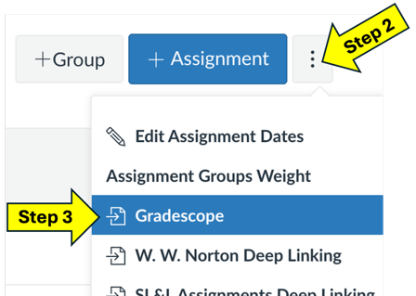
Because UO has purchased the enterprise edition of Gradescope, you can connect to it through a Canvas course. We recommend, for experimenting with Gradescope, using a developmental Canvas shell (a sandbox) rather than a course with students.
- In your canvas Course, go to the Assignments page.
- In the top-right corner, click on the button with three-dots.
- When the menu opens, select Gradescope from the list. An embedded window will open and, after a moment, log you into Gradescope. You will not need to input a password, as you already have done so when logging into Canvas.
  - The first time you do this, the window that opens will prompt you to link your Canvas course to a Gradescope course. If you do link a Canvas course and a Gradescope course, in the future the window will let you create a new Canvas assignment that is linked to a Gradescope assignment.

Part B: Creating a Course in Gradescope
It can be easiest to create a course directly in Gradescope’s website, rather than work from an embedded window inside of Canvas. After logging into Gradescope through Canvas, you can open Gradescope’s website in a new browser tab or window to access the Course Dashboard in Gradescope.
If you want to continue working in a window in Canvas, you can get the Course Dashboard by clicking on the Gradescope logo in the top-left corner of the window (you may need to first close any prompts that are open in the embedded window, such as creating a new course or assignment).

- When in the Course Dashboard, click on the “+ Create Course” button in the bottom left corner or click on the “Create A New Course” card in the dashboard.
- Give your course a number and name. We recommend matching information to what appears in Canvas. The number is your department and course number, not the CRN.
  - For exploring and experimenting with Gradescope, use name/numbering that helps you easily identify it as a testing space rather than a real course.
  - While not required, we recommend selecting a Term and Year for your course. These are helpful if you use Gradescope in many courses in the future (including when copying a course to reuse it!).
  - The “Entry Code” option will create a code that you can give to students to automatically enroll themselves in the course (if you do not add students yourself).
- Click the “Create Course” button. You now have a course in Gradescope!
- You should be taken your course’s Gradescope page. Familiarize yourself with it a bit and poke around to different links and menu options.

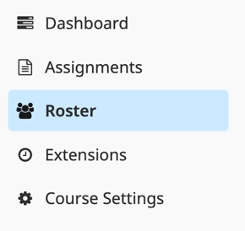
Part C: Adding Students Manually via Spreadsheet
You can add students to your Gradescope course many ways. We recommend linking a Canvas course and Gradescope course and then syncing your roster between them. To explore Gradescope, we will add (fake) students manually.
- In your course’s Gradescope page, click on the “Roster” menu item.
- You should see a list of people in your course – so far, just you! What is your role in the course?

- Click on the “+ Add Students or Staff” button. Select the Single User option.
  - What information is required to add someone to your course?
  - What other roles can you assign to people in the course?

- Cancel adding one person and instead add people by CSV file (a spreadsheet
format). Click the “Select CSV” button and upload our “TEPSampleRoster.cvs” file.
- After clicking the Next button, you should see a sample of our student list file. One column is empty. Which one? We need to fix that to correctly add students.
  - Our CSV file has first and last names in separate colors, not combined as a full name. Click on the blue “My CSV file has separate first and last name columns” link. Does it show names now?
  - Make sure you’ve selected the “Student” role for our roster file.
  - If you select the email notification option, students will be emailed that you added them to your Gradescope course. We do recommend this, but only after you talk about Gradescope with your students (otherwise they just will get a mysterious email about an unfamiliar website). Students in our CSV file have fake emails, so it does not matter what you select today.
  - Click the “Import” button to add students to your roster.
You now have students in your sample course. You can now move on creating assignments!

Bonus Task - Updating Roster Information
- On your Roster page, find Carl Reed. Carl is a TA, not a student but accidentally got mixed into our CSV file. How can you change his role?
- Jake Ryan and Farmer Ted moved to section 16, which previously had no students enrolled in it. We need to create that section and update these students’ information.
  - On the Roster page, find Jack Ryan. Edit his information by either clicking on Edit link that appears when you move your mouse over him in the list or by clicking on the pencil icon in the Edit column for him. This will open the Edit Course Member window for Jake.
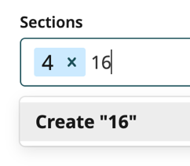
  - To make a new section, click in the Sections box, type “16” and press enter or click on ‘Create “16”’ under the box. Save Jake’s information. After you save the student’s information, the new section gets created and the student is added to it.
  - Find Jake in the roster. Which section(s) is he in? You can remove a student from a section by clicking the X next to a section number in the Edit Course Member window. Update Jake’s information so he is only in section 16.
  - Add Ted Farmer to section 16 using the drop-down list of sections (and remove him from section 4).
- Find Allison Reynolds and add her to a new section. Try to name this new section “Breakfast Club”. What happens when you try to create a section with a name, rather than a number?
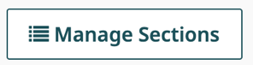
  - What information is shown in the Manage Sections button at the bottom of the Roster page?
  - Remove Allison from this new section you created. If you accidentally removed her from her original section, please add her back into section 3.
  - Go back to the Manage Sections page. Besides this new section having no students in it, what else has changed about this new section in the list?
  - Delete this new section. Can you delete any other sections? Why?

