Teaching Team

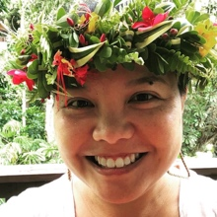
Rosie ‘Anolani Alegado
She/Her
Office: ROOM
Email: xxxxx@uoregon.edu
Rosie’s Zoom Link

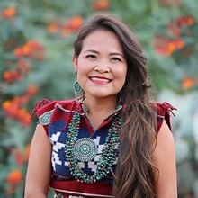
Karletta Chief
She/Her
Office: ROOM
Email: xxxxx@uoregon.edu
Karletta’s Zoom Link

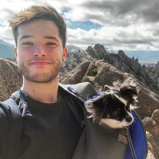
Sean Vidal Edgerton
He/Him
Email: xxxxx@uoregon.edu

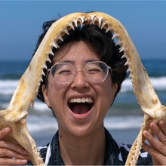
A-bel Gong
They/Them
Email: xxxxx@uoregon.edu

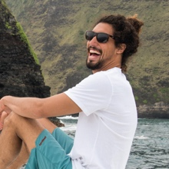
Cliff Kapono
He/Him
Office: ROOM
Email: xxxxx@uoregon.edu
Cliff’s Zoom Link

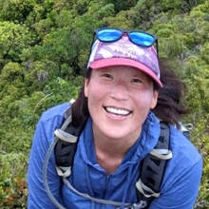
Tye Kindinger
She/Her
Email: xxxxx@uoregon.edu

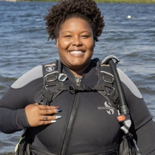
Tiara Moore
She/Her
Office: ROOM
Email: xxxxx@uoregon.edu

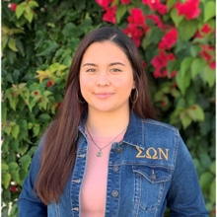
Maria Rocha
She/Her
Email: xxxxx@uoregon.edu

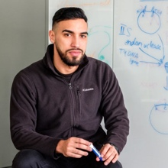
Luis Valentin-Alvarado
He/Him
Office: ROOM
Email: xxxxx@uoregon.edu
Luis’s Zoom Link

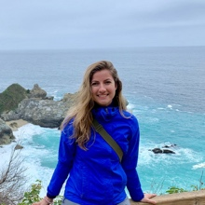
Meghan Zulian
She/Her
Office: ROOM
Email: xxxxx@uoregon.edu

GEs and LAs will host help/office hours at the Price Commons Science Library, Room B004A.

Scientists listed in this file come from The Scientist Spotlight Initiative. Links below go to their spotlight page and to the source for images (if different from spotlight page to find images in non-academic settings).
- Rosie ‘Anolani Alegado spotlight and Rosie ‘Anolani Alegado picture source
- Karletta Chief spotlight
- Sean Vidal Edgerton spotlight
- A-bel Gong spotlight
- Cliff Kapono spotlight and Cliff Kapono picture source
- Tye Kindinger spotlight
- Tiara Moore spotlight and Tiara Moore picture source
- Maria Rocha spotlight
- Luis Valentin-Alvarado spotlight and Luis Valentin-Alvarado picture source
- Meghan Zulian spotlight

