Not every tip is going to fit all contexts. Adopt ones that make sense for your course, the assignment, and your own style.If you are part of a teaching team, discuss grading expectations as a team. Make sure that any efficiency methods you use align with those expectations.

### General Advice for Efficient Grading

1. **Only grade and give feedback on critical material**. Focus on the learning objectives of the assignment. Leave comments that students can use to improve for later assignments.
2. **Skim samples of student work** before starting to understand common errors you’ll see.
3. **Grade question-by-question**. When your assignment can easily be broken into separate pieces (short answers, individual problems, etc.), grade one question for everyone before moving on to the next question. It is easier to remember the answer and your scoring rules for one question at a time than it is to remember the entire assignment’s answers and scoring. This also improves consistency in scoring across student work.
4. **Use a rubric**. Rubrics help grade efficiently by building a framework to guide your workflow, organizing your feedback, and can act as pre-written comments. In creating a rubric, you shift some of your grading time to before the assignment is due, hopefully reducing overall grading time. Rubrics also help promote consistency across multiple graders.

### Tips for Grading Grammar (or Math)

These cover a range of views on how important grammar is to an assignment’s learning objectives. In some cases, you can use similar methods for mathematical rigor and accuracy. Giving space for students to identify and fix errors encourages growth as critical evaluators of their own work.

1. **Ignore grammar** **errors**, unless they limit understanding. Then you can still apply a penalty.
2. **Only mark (e.g. circle, underline, highlight) grammar errors** but don’t comment on them.
3. **Comment when a new grammar error is made** but then only mark repeated errors.
4. **Copyedit just a portion of work**. If you need to give more careful grammar help, focus on just a couple of paragraphs to give detailed comments. As you grade more work later in the term, you can reduce your feedback on grammar to a simpler method as students improve.

### Tips for Time Management

1. **Build grading time into your schedule** by setting aside specific time to focus on grading.
2. **Set a time limit for each student submission**. Set a timer and quickly wrap up feedback when it goes off. If needed, you can adjust the time limit after grading a few assignments.
3. **Set grading goals** for how much work (e.g. a third of all essays) you’ll finishin one sitting.
4. **Take breaks**. Stretch. Eat a snack. Take selfies with a pet. Whatever helps you decompress.

### Tips for Giving Feedback Efficiently

1. **Use a comment bank when grading digitally**. Copy and paste comments you think you might use again into a Word Doc. When you want to make that comment again for a different student, it’s already written for you—just copy it into that student’s work!
2. **Build a Comment Library in Canvas’s SpeedGrader**. Click the blue speech bubble above the Assignment Comments box (see image on next page) to add new comments or to reuse existing comments. Each course has one Comment Library that gets shared between all assignments and all graders. Relying on it exclusively to store comments may become unwieldy after just a couple of assignments.
3. **Use comment coding**. Rather than writing the same comment repeatedly, add comments you think you might reuse in a Word Doc and assign them a number or short code phrase. Write (or type) just the number or phrase on student work and share your Word Doc with students to decode your feedback. For example, writing “C15” or “tangent” near text you’ve marked could direct students to a comment that says “This doesn’t feel related to topic. Clarify and strengthen their relationship.” Useful feedback was given with minimal writing.

Double-digit comment coding uses two numbers (for example, 3-2) as the comment code. Here are two ways to use it:

1. **Use double-digit comment coding with a rubric**. The first digit refers to one rubric criterion and the second to a specific comment. For example, code “3-2” tells the student to look at criterion three’s second comment for their feedback. These comments are different from the descriptions already in the rubric. Instead, they help explain why students earned a specific rating for that criterion or offer suggestions of how to move up to a higher rating.
2. **Use double-digit comment coding to score short answer questions**. The first digit is the numeric score you’ve assigned the answer, and the second digit is a specific comment for that score. For example, code “3-2” tells a student that they earned three points, and they can find out why from the second comment for three-point scores.

### Try Alternative Ways to Leave Feedback

1. **Summarize feedback for the class** when there are common mistakes by many students. Discuss it in class or share a document or video in Canvas. This will help familiarize students with common errors and ways to improve their work, even if they didn’t make the specific errors *this time*. If you use a rubric, comment bank, or comment coding, use tally marks to track how many times you used each item and help find trends in student work.
2. **Invite students to office hours** to talk one-on-one about their work with you. This doesn’t have to be exclusively used for poor work. Make students know that when inviting them.
3. **Record audio or video feedback** in Canvas’s SpeedGrader. It can be accessed with the camera icon below the Assignment Comments box (see image below). Use it for quicker whole assignment feedback, instead of using it for a line-by-line critique.

The Comment Library and Audio/Video Feedback buttons in Canvas’s SpeedGrader.

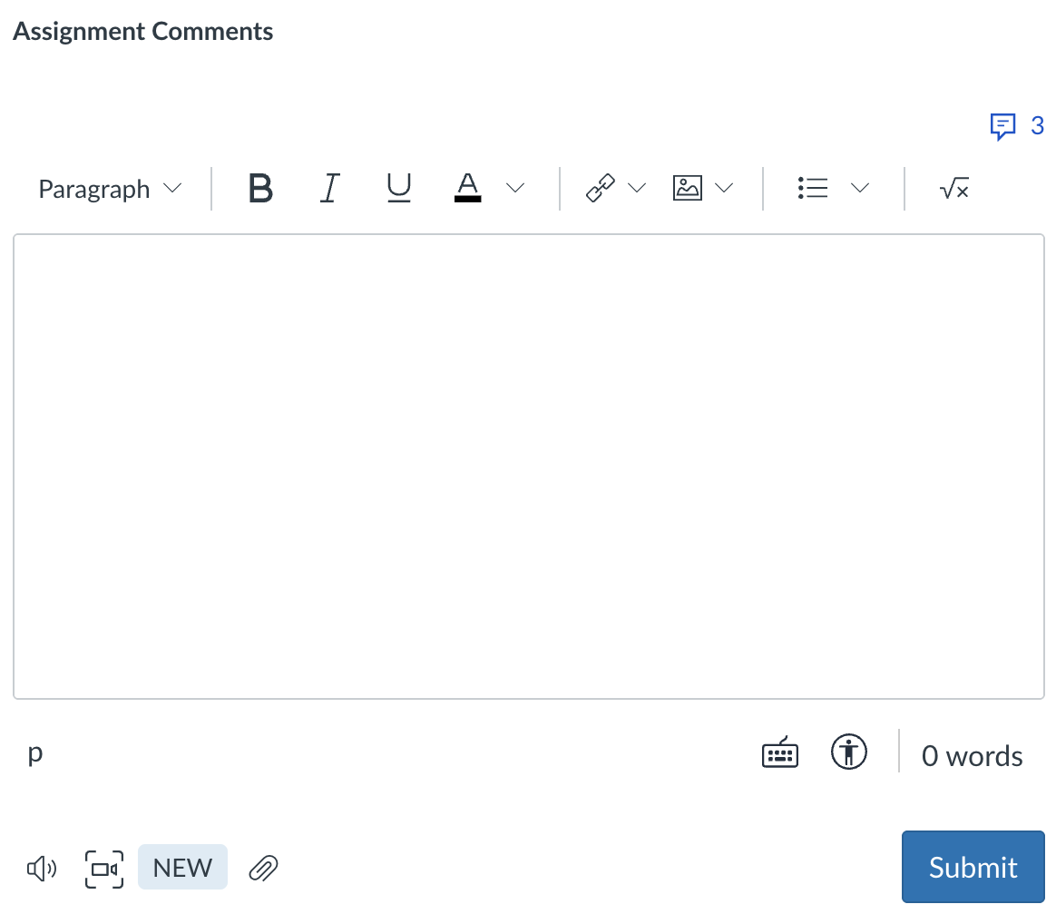

**Open Comment Library**

**Record Audio/Video Feedback**