Mike’s Revision Tool

A Word About Ordering a Paragraph …
You may have heard about funnels and pyramids. They represent either deductive (funnel) or inductive (pyramid) forms, which are not the only ways to shape a paragraph. It really depends on your strategy, which, itself, depends on your reading of the audience. Here are some different kinds of paragraphs you might deploy in your writing:

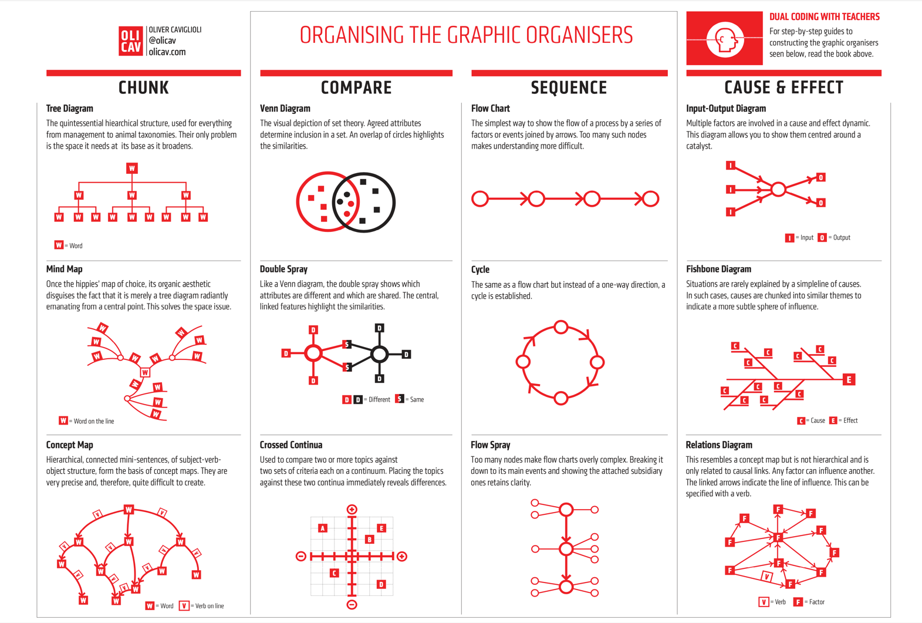
*One thing to remember is that you’ll have to LINEARALIZE these forms to fit the reading experience. This comes from Oliver Caviglioli’s Dual Coding for Teachers (John Catt Educational, 2019)
The Actual Writing Process from Rough Draft to Polished Final
This is not meant to be a Step-By-Step guide, but a Process Map for understanding all of the pieces of a complete process. The reality is that you’ll skip steps, things might be in a different order for you, or that specific areas of a piece of writing develop along different timelines. That’s okay. The point is that you have a general understanding of the entire process, from beginning to end, so you can adjust to fit a timeline, that you can get a clearer idea of where you are in the writing process, and that the process can adjust to accommodate your process and your thinking.

 | What you’re trying to say |  | Pivot toward Linearity |  | What a reader needs to hear
 | Prewriting | Drafting Your Ideas | Plan for the Final Copy | Rewriting the Piece | Revising the Rewrite | Refine the Revision
What you need done before you start | - Daily Writing  - SPAM AV to focus and as self-diagnostic | - Prewriting  - Daily Writing | - Rough draft  - Do the Math  - Feedback | - Rhetorical map  - Daily Writing | - Rewritten Draft  - Daily Writing | - Revised Draft  - Feedback  - Daily Writing  - Order of operations
Minimum elements  needed to begin | - Subject  - Audience | - Subject  - Purpose  - Audience | - Subject  - Purpose  - Audience, refined  - Working argument | - The rhetorical moves from paragraph to paragraph  - Argument refined  - Examples  - Evidence  - Proofs  - Citations | - The Refined Rhetorical Structure  - Refined Argument  - Evidence and Proofs finalized  - Citations completed | - Rhetorical refinement
What you’re searching for & hope to have by the end | - Purpose, at least  - Maybe a working argument | - Argument, at least | - Plan of the structure based on Argument and Audience | - Complete draft with rough rhetorical structure | - Rhetorical strategy, paragraph by paragraph  - Addressing the cognitive gaps | - Sentence-by-sentence rhetorical shape  - Expert feedback
Strategies you’ll use | - Timed trials  - Looping as in Mike’s IP4AA (Instant Pot for Argument Acquisition) | - Circular writing strategies that you typically use to draft  - Timed writing  - Task switching | - After-the-fact outline  - The Math  - Focus on topic sentence | - After-the-after-the-fact outline | - Transitions between sections and paragraphs  - Incorporate feedback response | - In-paragraph rhetorical mapping  - In-paragraph transitions
Activities you’ll engage in | - Journaling  - Brainstorming  - Categorizing and Reorganizing  - Looping  - Diagraming  - Early feedback  - Cubing, etc. | - Looping  - Circular writing, attempts at linearity  - Get Feedback at end of this | - SPAM AV, again  - Know audience  - Rhetorical mapping  - Gather additional evidence, example, proofs, citations | - Use the Plan of the structure and After-the-after-the-fact outline to rewrite  - Grammar | - Topic Sentences  - Order of Operations  - Grammar  - Get Feedback at end of this | - Grammar  - Transition  - Order of Operations  - Feedback
Minimum Goal | - Subject  - Purpose  - Audience  - Argument would be nice though not required | - Draft with a beginning, middle, and end  - Feedback | - Working plan for the structure  - Usually in the form of an outline | - Refined Argument and basic proofs  - Beginning of Rhetorical Structure  - Efficient Writing | - Efficient Writing  - Maybe Elegant Writing | - Elegant Writing  - Maybe Engaging and Powerful Writing

Do the Math
You’re writing an article for a journal with a 5,000 word cap. If a well-developed paragraph is roughly 200 to 250 words, that means you’ll have 20 to 25 paragraphs total (and you’ll have to subtract paragraphs for tables, charts, graphs, and graphics, accordingly). You also know your writing, so, if you tend to write in the 300-range, adjust your paragraph numbers down.

In this example, we’ll figure an article with just text. You’ll likely want 2 paragraphs for an introduction and another paragraph for the conclusion. This leaves you between 18 and 23 paragraphs to make all of your rhetorical moves to get your audience to your Purpose.

This is where you begin to devise the structure of the argument. How, in 18 to 23 paragraphs, will you state, explain, and prove your argument to your audience? At this point, you may want to just imagine a general audience, without regard to who will be reading. But if you’ve done the SPAM AV Worksheet, then you probably have an idea of who your audience is, and their general disposition to your Subject, Purpose, and Argument. The point, here, is that if you know you have 18-23 individual steps to manipulate your reader into position to achieve your purpose, you can better plan the Rewrite. It’s not difficult to begin. It just takes a little getting into the process.

Order of Operations example
Passive verbs
Adverb containment
Transitions and Topic sentences
Concluding sentences
S-V-O relationship and Clauses
Nominalizations
Prepositions
Pronouns

Central Argument
While the process of thinking and drafting are circular, reading, by its very nature, is linear. Because the mismatch between the circularity of drafting and the linearity of reading lies at the heart of the writing process, more than any other factor, this seeming contradiction explains the difficulty academic authors face in writing polished scholarship. I believe that efforts to write, our strategies and techniques, therefore, must account for this mismatch. It would not be inaccurate to say that the scholarly writing process, from draft to rewrite to revision to refinement, is a process of converting the circular into the linear and that the struggle to produce elegant and engaging scholarly prose is most often marked by this conflict between the two — the circularity of thinking and the linearity of reading.

