Document Title

Information based on Ryerson University Understanding Document Accessibility Pressbook

Heading 1
Text

Heading 2
Text

Heading 3
Text
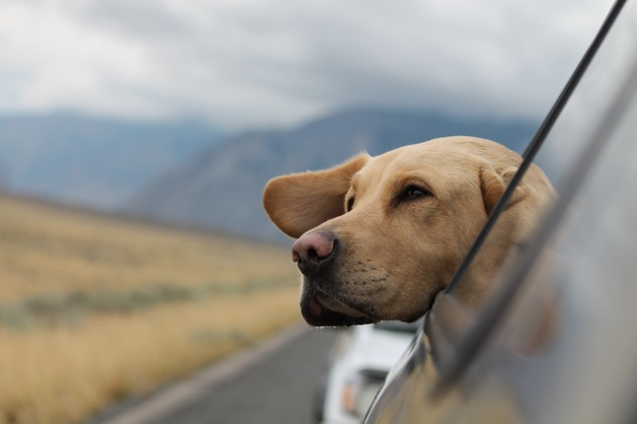

Reasons why dogs are great (unordered list):
- Good companions
- Loyal
- Intelligent
- Can provide a calming influence

Top 3 dog breeds in Canada (ordered list):
- Labrador Retriever
- German Shepherd
- Golden Retriever

Tables

Reference: National Center for Accessible Media (NCAM) at WGBH Information on designing accessible data tables
Substance | Density
Oil | .8 g/mL
Water | 1.0 g/mL
Plastic | .9 g/cm³
Rock | 4.2 g/cm³
Aluminum | 2.3 g/cm³

A table listing five substances and the density of each one.
Oil .8g/mL
Water 1.0g/mL
Plastic .9g/cm³
Rock 4.2g/cm³
Aluminum 2.3g/cm³

Plastic | Acetone | Flame Test | Heat | Crease Color
1 | No effect | Green color | Softens | None
2 | Softened | No change | No change | White
3 | No effect | Red color | Softens | None
4 | No effect | Green color | Softens | None

